**User Management II**

**TO ADD A USER INTO A GROUP:**

* useradd -G groupname username

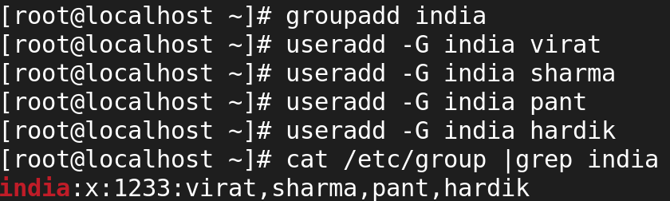

**USERADD WITH PREDEFINED PARAMETER:**



**useradd -e '2024-01-01' username**

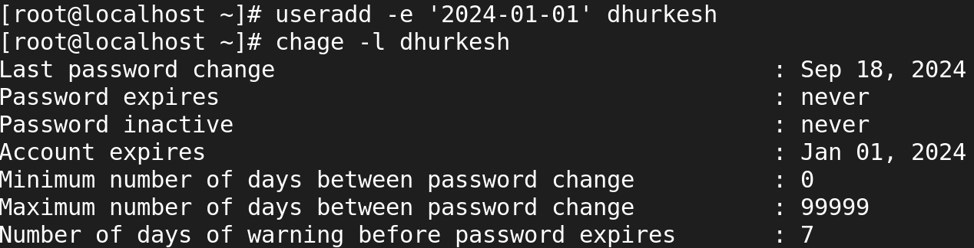

**useradd -M username 🡪** It used to create a user without creating a directory.

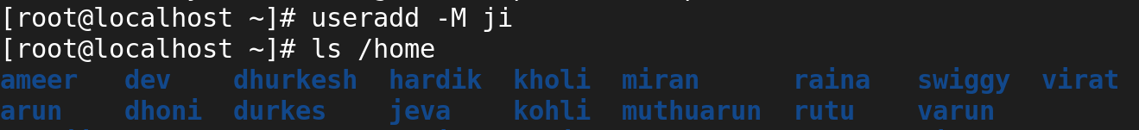

**USERMOD**

**TO RENAME USER'S ACCOUNT NAME:**

* **usermod -l newname oldname**

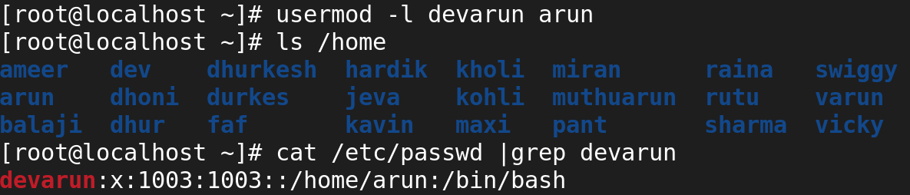

**TO CHANGE USER'S UID:**

* **usermod -u 1899 username**

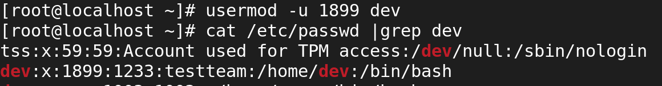

**TO CHANGE USER'S GID:**

* **usermod -g 1233 username**



**CHANGING THE USER INFORMATION:**

* **usermod -c "Test User" username**

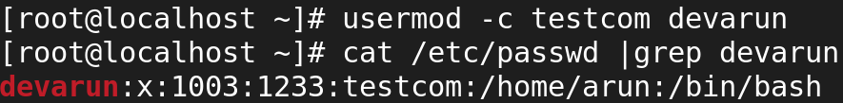

**Locking and Unlocking a User Account**

**LOCK**

* **usermod -L username**
* The user's password is "locked" by adding an exclamation mark (!) at the beginning of the password hash in /etc/shadow.

**L 🡪**This option locks the user's password, effectively disabling their ability to log in.



**UNLOCK**

* **usermod -U username**



**TO CHECK THE USER'S ID OR UID WITH GROUP ID**

* **id username**



**TO VERIFY THE USER'S PASSWORD INFORMATION**

* **chage -l username**

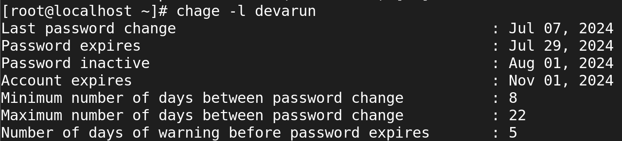

**TO CHANGE USER'S MINIMUM PASSWORD EXPIRY DATE**

* **chage -m 5 username**

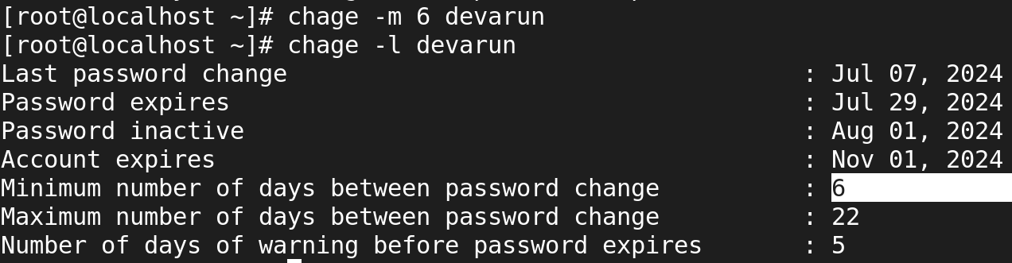

**TO CHANGE USER'S MAXIMUM PASSWORD EXPIRY DATE**

* **chage -M 20 username**

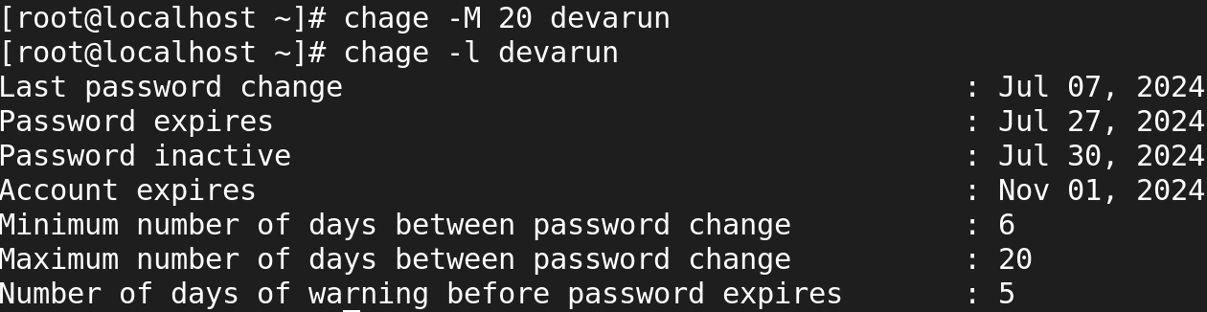

**TO CHANGE USER'S MINIMUM PASSWORD EXPIRY WARNING DATE**

* **chage -W 15 username**

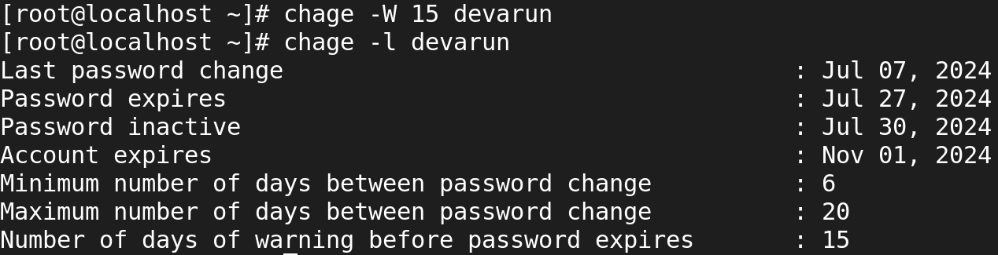

**TO CHANGE USER'S PASSWORD INACTIVE DATE**

* **chage -I 9 username**

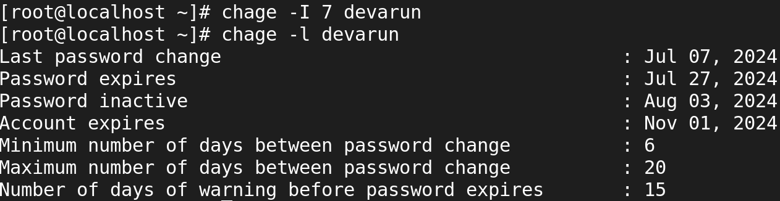

**TO CREATE GROUP**

* **groupadd groupname**

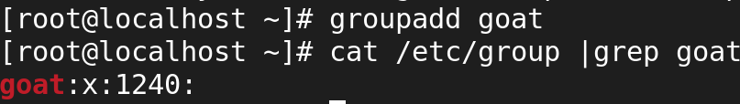

**ADD USER INTO A GROUP**

* **gpasswd -a user group**

**(or)**

* **usermod -a -G group user**

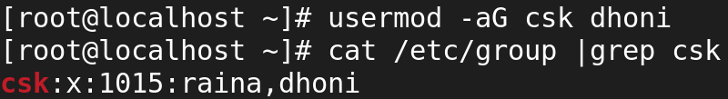

**TO CHANGE GROUP'S GID**

* **groupmod -g 1033 groupname**

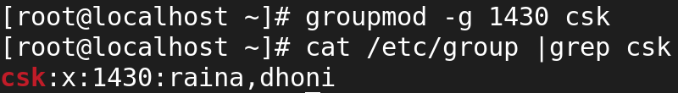

**TO RENAME A GROUP**

* **groupmod -n newgroup oldgroup**

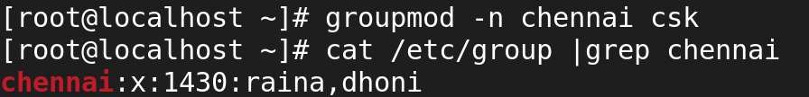

**LOCK THE USER PASSWORD**

* **passwd -l username**

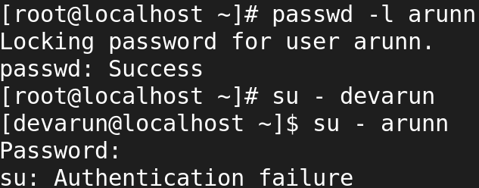

**UNLOCK THE USER PASSWORD**

* **password -u username**

